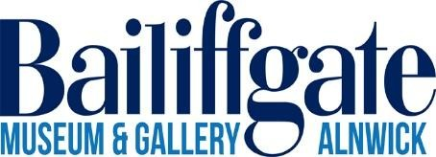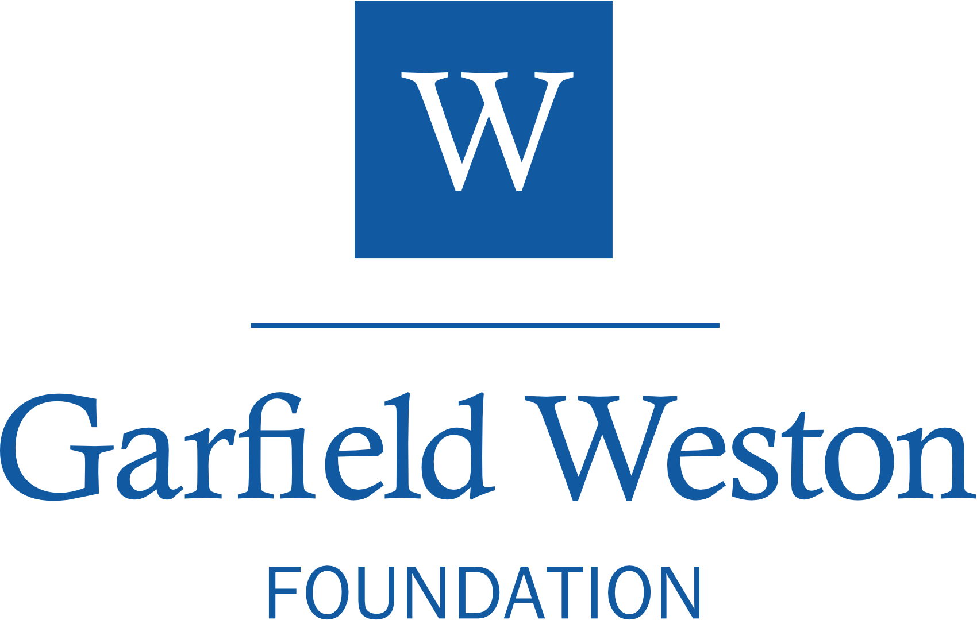

Volunteer-led People’s Museum in Northumberland awarded £200,000 by the Garfield Weston Foundation.

Bailiffgate Museum & Gallery in Alnwick Northumberland is absolutely thrilled by the announcement that it has received funding from Garfield Weston Foundation towards the cost of restoring Northumberland Hall to create a new home for the museum.

This money takes us closer to commencing the main works on site and will go towards the overall project to restore and repair the beautiful Grade 1 listed Northumberland Hall which will contribute to the realisation of a long-awaited ambition to transform the Bailiffgate Museum & Gallery into a home for the people, stories, and art, of rural and North Northumberland. This new Bailiffgate Museum & Gallery is at the core of wider plans to regenerate Alnwick and strengthen Alnwick’s vibrant town centre economy.

The vision to transform Northumberland Hall into the museum's new home includes refurbishment and renovation of the building and the creation of inspirational interpretation of the Bailiffgate Museum & Gallery collections. The reimagined museum and gallery will be a vibrant base for new permanent exhibitions of stories of the town and compelling and exciting temporary exhibitions. Through this the Museum will continue to be beloved of local residents, as well as becoming a fascinating experience for visitors.
A volunteer run, operated, and led charity, this funding supports Bailiffgate Museum & Gallery at a critical point in its development. Through the dedication of their volunteers the award-winning museum has grown significantly in reputation, scope and reach over the last decade. A move to Northumberland Hall will help continue this growth, whilst supporting community ventures, showcase local creatives, provide meeting space for volunteers and local groups, engage new audiences, and grow visitor numbers.
Northumberland Hall was originally built in 1826 for the third Duke of
Northumberland and has been under-used for several years. This project will see the Grade I Listed building revitalised and brought back into productive use. The transformed market hall will be a beating heart at the centre of a bold new vision to regenerate the centre of Alnwick, situating the stories of the people of the town and as well as rural and North Northumberland front and centre. Works are scheduled to commence on the building in late Spring 2026.
Jean Humphrys, the Chair at Bailiffgate Museum & Gallery, said “Trustees and volunteers at Bailiffgate are thrilled to have been given this grant to contribute to the the refurbishment of Northumberland Hall. We are local people, with a passion for Alnwick and Northumberland, its history and its culture and we are delighted to have this unique opportunity to make an exciting contribution to revitalising the town for the community and its visitors".

Bailiffgate Museum & Gallery are looking for volunteers across a wide range of activities, and there will be events and activities taking place throughout the project, listed on the museum’s social media channels and website https://bailiffgatemuseum.co.uk/.
Notes to editors

About Bailiffgate Museum & Gallery
Bailiffgate Museum & Gallery is an award-winning, volunteer-run People’s Museum based in Alnwick, Northumberland. Housed in what was previously a church close to Alnwick Castle, Bailiffgate preserves, maintains and continues to tell the fascinating stories which celebrate the heritage of Alnwick and the district.
Displayed across three floors, visitors can explore a large collection of items on permanent display, as well as a diverse programme of interesting temporary exhibitions and events. The Museum and its dedicated team of volunteers aim to provide an excellent community, educational and tourist resource to the North East.
Winner of the Kids in Museums 2021 Family Friendly Museum Award, Bailiffgate Museum & Gallery has been recognised as one of the best places in the country for early years children to visit. Great for children and adults alike, Bailiffgate details the stunning county and characters of Northumberland.

About Garfield Weston Foundation
The Garfield Weston Foundation is a family founded grant-maker supporting charities operating in a wide variety of sectors across the UK that make a positive difference within their communities.

Established by W. Garfield Weston in 1958 through an endowment of shares in the family business – now known as Associated British Foods plc – the Foundation continues to be guided by the Weston Family. The Trustees, each of whom are direct descendants of the founder, play an active, informed role in its work.

This successful model has ensured that our charitable donations have grown as the businesses have grown, enabling the Foundation to award grants totalling nearly £1.7 billion since its establishment. The most recent financial year 2024-2025 saw the Foundation give away almost £130 million to 2,967 charities.

Further information
Marketing Team marketing@bailiffgatemuseum.co.uk Museum Coordinator: 01665 605847 ask@bailiffgatemuseum.co.uk
Tel 01665 605847
Find us on Twitter and Facebook http://www.bailiffgatemuseum.co.uk
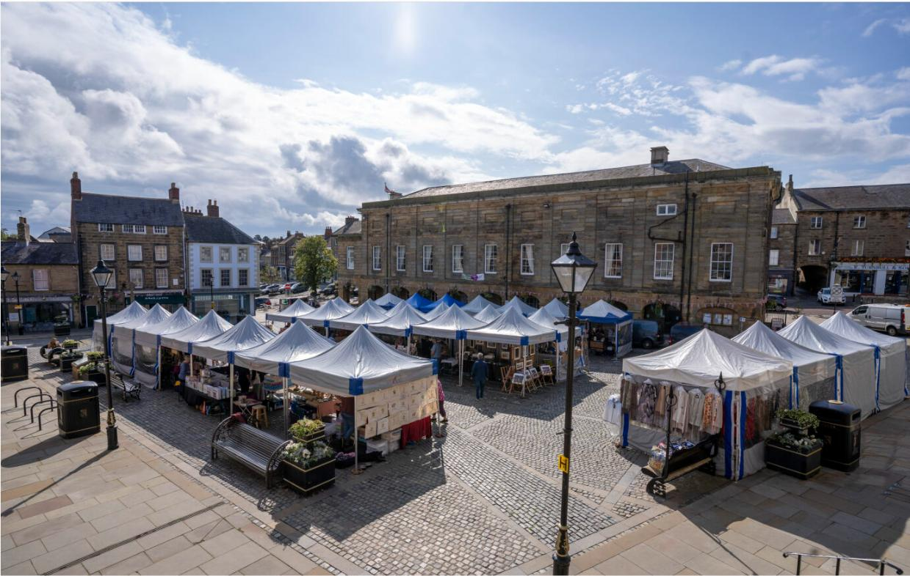
Northumberland Hall, Alnwick, viewed across the Marketplace. ©Bailiffgate Museum & Gallery.

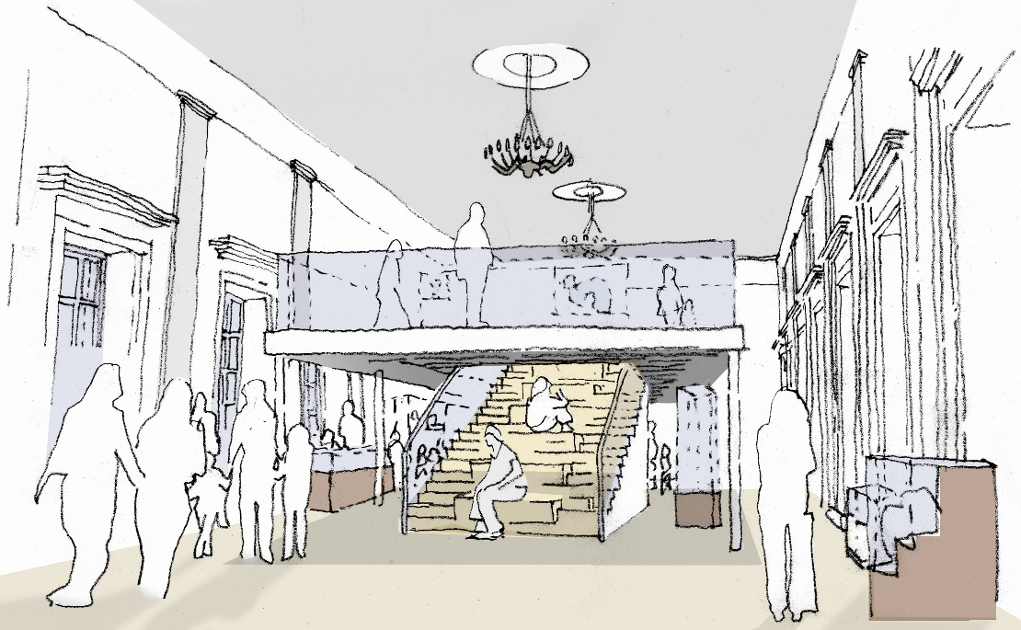

Architects Impression of the New Northumberland Hall. ©Mosedale Gillatt Architects Ltd.

